Shaping Data

Normalization
- Created view - sp500data_norm (Normalized data for easier comparison, created scores 0-100 rounded to 2 decimal places for consistency when comparing)
CREATE OR REPLACE VIEW `projectspractice12.sp500dataAnalysis.sp500data_norm` AS
SELECT
symbol,
name,
sector,
price,
priceToEarnings,
dividendYield,
EarningPerShare,
WeekLow52,
WeekHigh52,
marketCap,
ebitda,
PriceToSales,
priceToBook,
ROUND(
100 * (MAX(priceToEarnings) OVER() - priceToEarnings)
/ NULLIF(MAX(priceToEarnings) OVER() - MIN(priceToEarnings) OVER(), 0), 2
) AS pe_norm,
ROUND(
100 * (ebitda - MIN(ebitda) OVER())
/ NULLIF(MAX(ebitda) OVER() - MIN(ebitda) OVER(), 0), 2
) AS ebitda_norm,
ROUND(
100 * (dividendYield - MIN(dividendYield) OVER())
/ NULLIF(MAX(dividendYield) OVER() - MIN(dividendYield) OVER(), 0), 2
) AS divy_norm,
ROUND(
100 * (MAX(PriceToSales) OVER() - PriceToSales)
/ NULLIF(MAX(PriceToSales) OVER() - MIN(PriceToSales) OVER(), 0), 2
) AS ps_norm,
ROUND(
100 * (MAX(priceToBook) OVER() - priceToBook)
/ NULLIF(MAX(priceToBook) OVER() - MIN(priceToBook) OVER(), 0), 2
) AS pb_norm,
FROM `projectspractice12.sp500dataAnalysis.sp500data_clean_step2`
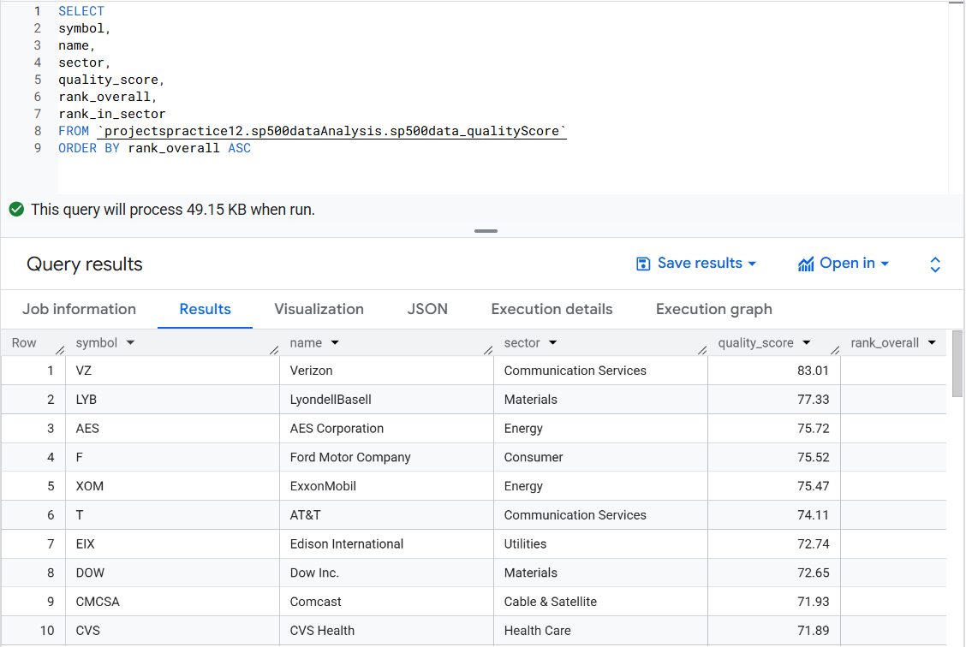
- Quality Score & Ranks
Created view - sp500data_qualityScore (Used sp500data_norm view, quality score determines if a company is a good investment, ROW_NUMBER and DENSE_RANK window functions used for ranking)

CREATE OR REPLACE VIEW `projectspractice.sp500dataAnalysis.sp500data_qualityScore` AS
SELECT
symbol,
name,
sector,
price,
marketCap,
priceToEarnings,
Pe_norm,
ebitda,
ebitda_norm,
dividendYield,
divy_norm,
PriceToSales,
ps_norm,
priceToBook,
pb_norm,
ROUND( (pe_norm + ebitda_norm + divy_norm + ps_norm + pb_norm) / 5, 2 ) AS quality_score,
ROW_NUMBER() OVER (ORDER BY (pe_norm + ebitda_norm + divy_norm + ps_norm + pb_norm) DESC) AS rank_overall,
DENSE_RANK() OVER (PARTITION BY sector ORDER BY (pe_norm + ebitda_norm + ps_norm + pb_norm + divy_norm) DESC) AS rank_in_sector
FROM `projectspractice.sp500dataAnalysis.sp500data_norm`;

- Rank
SELECT
symbol,
name,
sector,
quality_score,
rank_overall,
rank_in_sector
FROM `projectspractice.sp500dataAnalysis.sp500data_qualityScore`
ORDER BY rank_overall ASC

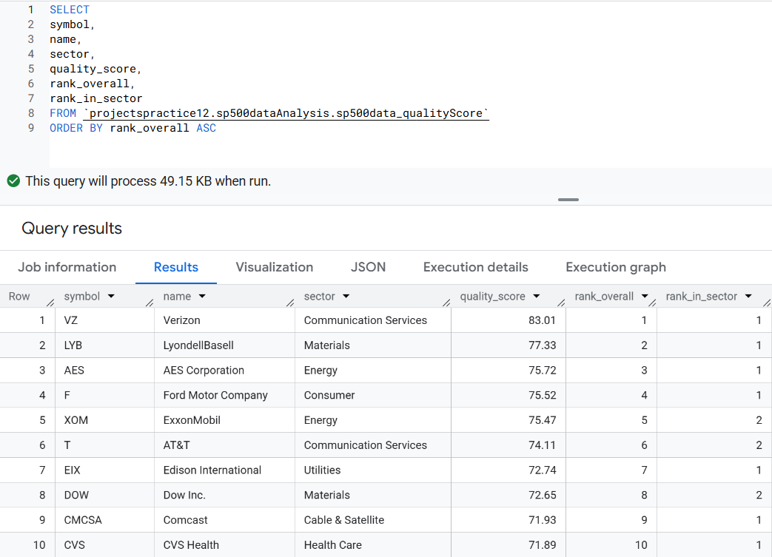

- Sector Summary (Round quality_score to 2 decimal places, narrowed down number of sectors to 36 sectors from 127 sectors, ordered by avg_quality_score making sector comparison easier)
Created Table - sp500data_qualityScore_sector

CREATE OR REPLACE TABLE `projectspractice12.sp500dataAnalysis.sp500data_qualityScore_sector` AS
SELECT
sector,
ROUND(AVG(quality_score), 2) AS avg_quality_score,
COUNT(*) AS n_symbols
FROM `projectspractice.sp500dataAnalysis12.sp500data_qualityScore`
GROUP BY sector
ORDER BY avg_quality_score DESC;

